CMISST forecasts
Brian Burke

CMISST

Covariance Map Index of Seas Surface Temperature

60°N
50°N
Latitude
40°N
30°N
20°N
10°N
Spring CMISST MapCovariance
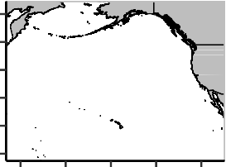
0.6

0.3

0.0

−0.3

Age

avg_age1 avg_age2 avg_age3 avg_age4

160°E180°160°W140°W120°W

Longitude
−0.6

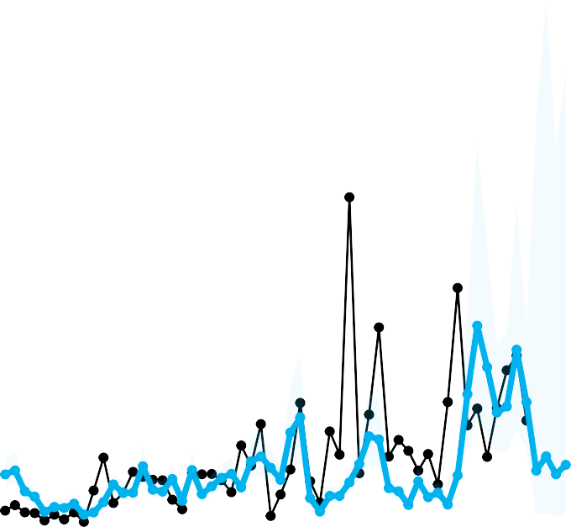
1.5e+07

1.0e+07
Alagnak

5.0e+06

0.0e+00

1980 | 2000 |  | 2020
year | fit | lwr | upr
55 2021 | 1794978 | 227667.6 | 14151978
56 2022 | 2290555 | 288615.1 | 18178678
57 2023 | 1665232 | 211470.0 | 13112953
58 2024 | 1995597 | 252512.7 | 15771120
Weighted Mean Forecast: 2049942

Spring CMISST MapCovariance
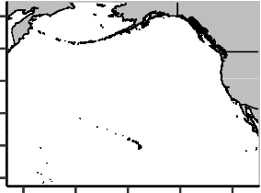
60°N

Age

50°N
Latitude
40°N
30°N
20°N
10°N
160°E180°160°W140°W120°W

Longitude
0.3

0.0

−0.3
avg_age1 avg_age2 avg_age3 avg_age4

3e+07

2e+07
Egegik

1e+07

0e+00

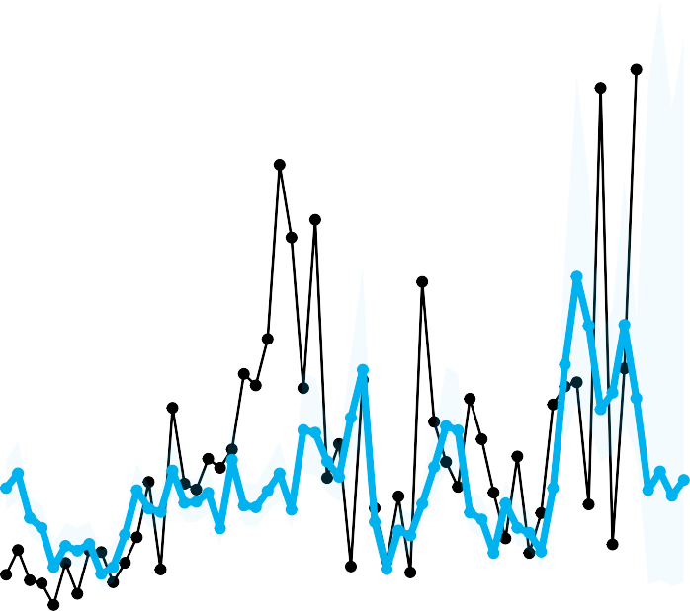

1980 2000 2020

year | fit | lwr | upr
55 2021 | 6022570 | 1397063 | 25962566
56 2022 | 6940836 | 1606658 | 29984734
57 2023 | 5746466 | 1333307 | 24766901
58 2024 | 6527149 | 1512696 | 28164061

Weighted Mean Forecast: 6290542

Spring CMISST MapCovariance

60°N

Age

50°N
Latitude
40°N
30°N
20°N
10°N
160°E180°160°W140°W120°W

Longitude
0.3

0.0

−0.3
avg_age1 avg_age2 avg_age3 avg_age4

4e+06

3e+06

2e+06
Igushik

1e+06

0e+00
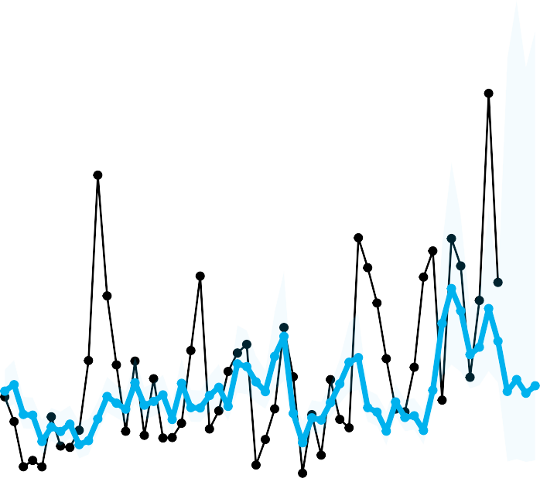

1980 2000 2020

year | fit | lwr | upr
55 2021 | 769771.3 | 162171.3 | 3653840
56 2022 | 872737.0 | 183204.3 | 4157489
57 2023 | 754043.0 | 158907.7 | 3578057
58 2024 | 819002.9 | 172299.4 | 3893024

Weighted Mean Forecast: 836770

60°N
50°N
Latitude
40°N
30°N
20°N
10°N
Spring CMISST MapCovariance
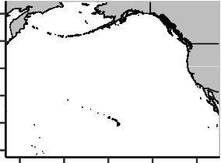
0.4
0.2
0.0
−0.2

Age

avg_age1 avg_age2 avg_age3 avg_age4

160°E180°160°W140°W120°W

Longitude
−0.4

5e+07

4e+07

3e+07
Kvichak

2e+07

1e+07

0e+00

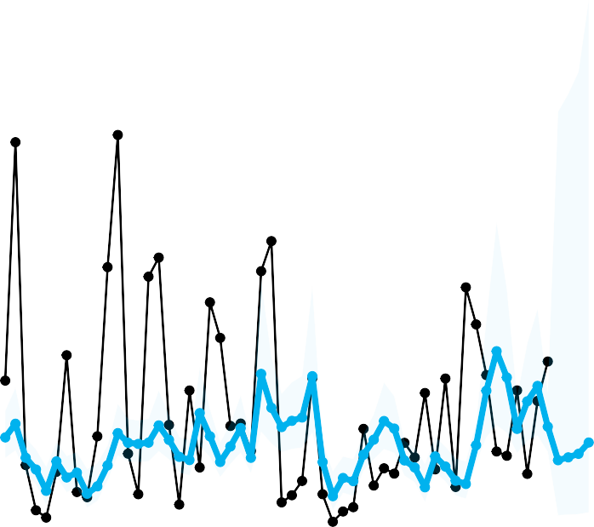

1980 2000 2020

year | fit | lwr | upr
55 2021 | 6228888 | 981740.6 | 39520671
56 2022 | 6504421 | 1026266.5 | 41224669
57 2023 | 6843473 | 1080627.5 | 43338828
58 2024 | 7922726 | 1250482.0 | 50196312

Weighted Mean Forecast: 6761611

60°N
50°N
Latitude
40°N
30°N
20°N
10°N
Spring CMISST MapCovariance
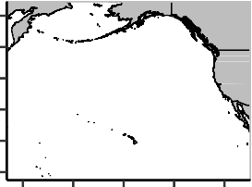
0.6
0.3
0.0
−0.3

Age

avg_age1 avg_age2 avg_age3 avg_age4

160°E180°160°W140°W120°W

Longitude
−0.6

1.2e+07

8.0e+06
Naknek

4.0e+06

0.0e+00

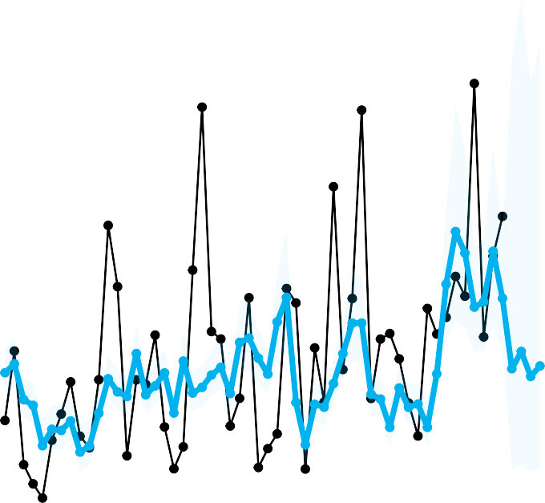
1980 2000 2020

year fit lwr upr
55 2021 4398840 1419139 13634876
56 2022 4907393 1578763 15254041
57 2023 4171439 1346588 12922215
58 2024 4481151 1445220 13894568

Weighted Mean Forecast: 4599868

Spring CMISST MapCovariance

60°N

Age

50°N
Latitude
40°N
30°N
20°N
10°N
160°E180°160°W140°W120°W

Longitude
0.4

0.0

−0.4
avg_age1 avg_age2 avg_age3 avg_age4

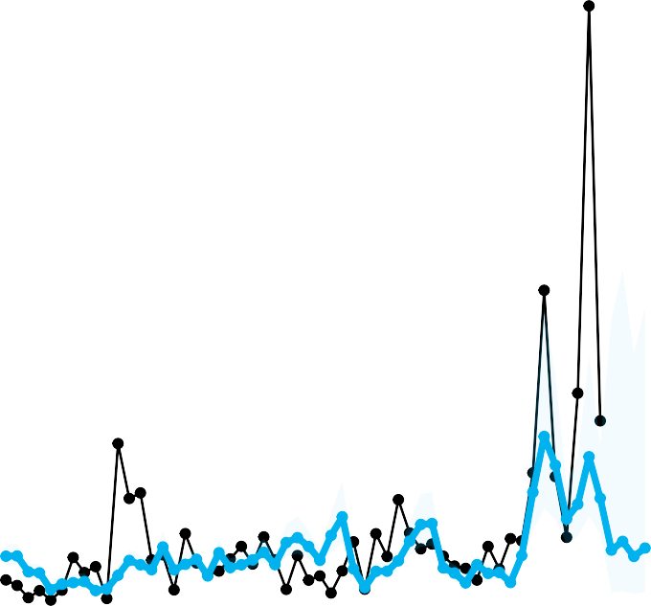
2.0e+07

1.5e+07
Nushagak

1.0e+07

5.0e+06

0.0e+00

1980 | 2000 |  | 2020
year | fit | lwr | upr
55 2021 | 2019483 | 371352.9 | 10982306
56 2022 | 2356869 | 431605.7 | 12870159
57 2023 | 1775478 | 327114.4 | 9636762
58 2024 | 2100540 | 385924.1 | 11432990
Weighted Mean Forecast: 2214898

60°N
50°N
Latitude
40°N
30°N
20°N
10°N
Spring CMISST MapCovariance

0.6
0.3
0.0
−0.3

Age

avg_age1 avg_age2 avg_age3 avg_age4

160°E180°160°W140°W120°W

Longitude
−0.6

2e+07
Ugashik

1e+07

0e+00

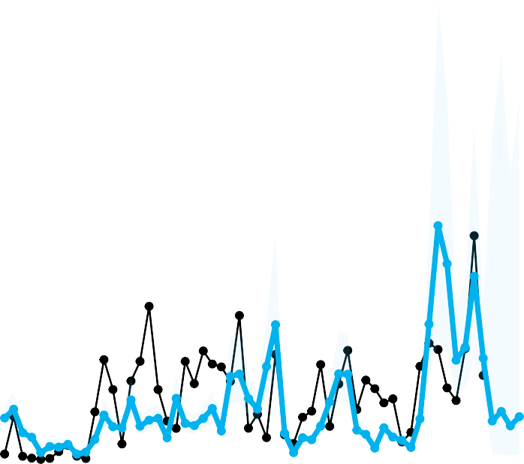
1980 2000 2020

year | fit | lwr | upr
55 2021 | 2338749 | 279822.1 | 19547235
56 2022 | 2913514 | 348015.9 | 24391302
57 2023 | 2048494 | 245037.5 | 17125239
58 2024 | 2599037 | 310816.6 | 21733054

Weighted Mean Forecast: 2419158

Spring CMISST MapCovariance

60°N

Age

50°N
Latitude
40°N
30°N
20°N
10°N
160°E180°160°W140°W120°W

Longitude
0.4

0.0

−0.4
avg_age1 avg_age2 avg_age3 avg_age4

2.5e+07

2.0e+07

1.5e+07
Wood

1.0e+07

5.0e+06

0.0e+00

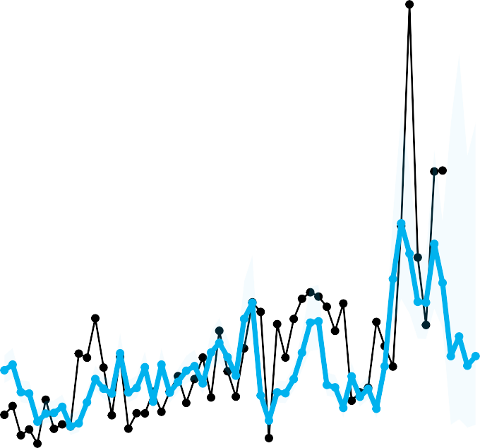
1980 2000 2020

year fit lwr upr
55 2021 5271304 1550992 17915408
56 2022 6335400 1854005 21648970
57 2023 4754258 1401269 16130362
58 2024 5271661 1551094 17916647

Weighted Mean Forecast: 5512501

60°N
50°N
Latitude
40°N
30°N
20°N
10°N
Spring CMISST MapCovariance
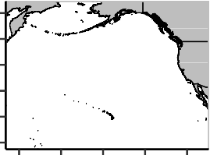
0.50

0.25

0.00

−0.25

Age

avg_age1 avg_age2 avg_age3 avg_age4

160°E180°160°W140°W120°W

Longitude
−0.50

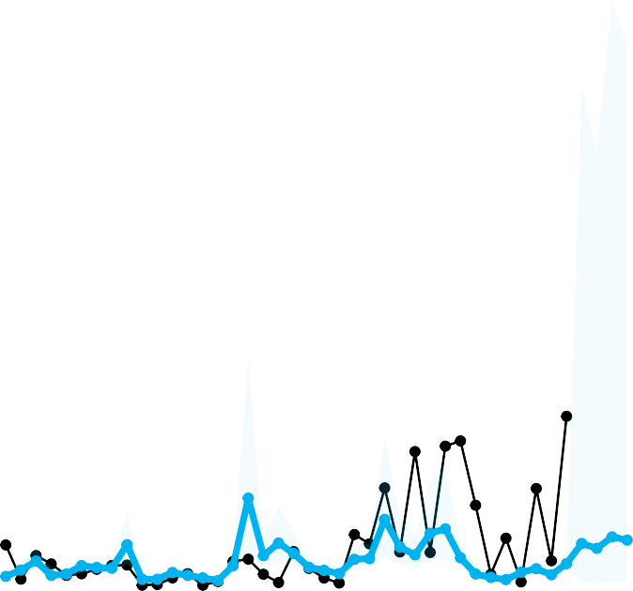
2500000

2000000
Bonneville Lock & Dam

1500000

1000000

500000

0
1990 2000 2010 2020

year | fit | lwr | upr
39 2021 | 177881.0 | 15189.10 | 2083181
40 2022 | 157561.0 | 13617.99 | 1822989
41 2023 | 205270.3 | 17237.46 | 2444439
42 2024 | 191880.9 | 16245.59 | 2266355

Weighted Mean Forecast: 199172

60°N
50°N
Latitude
40°N
30°N
20°N
10°N
Spring CMISST MapCovariance
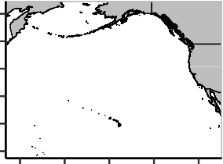
0.2
0.1
0.0
−0.1
−0.2

Age

avg_age1 avg_age2 avg_age3 avg_age4

160°E180°160°W140°W120°W

Longitude
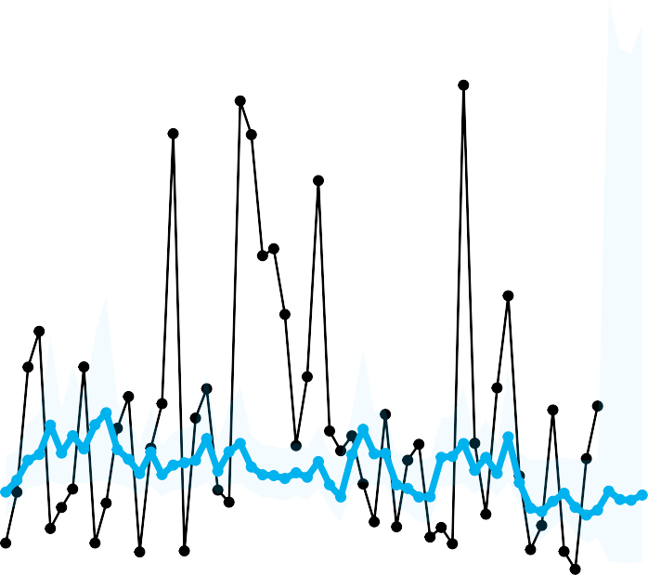
6e+06

4e+06
Chilko

2e+06

0e+00
1980 2000 2020

year | fit | lwr | upr
55 2021 | 824875.0 | 117726.7 | 5779648
56 2022 | 740122.5 | 103757.1 | 5279460
57 2023 | 733045.8 | 102568.5 | 5238997
58 2024 | 785454.9 | 111292.3 | 5543417

Weighted Mean Forecast: 734729

Spring CMISST MapCovariance
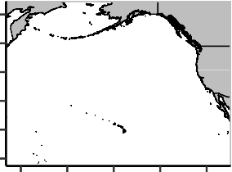
60°N

Age

50°N
Latitude
40°N
30°N
20°N
10°N
160°E180°160°W140°W120°W

Longitude
0.2

0.0

−0.2
avg_age1 avg_age2 avg_age3 avg_age4

4e+06
Late Stuart

2e+06

0e+00

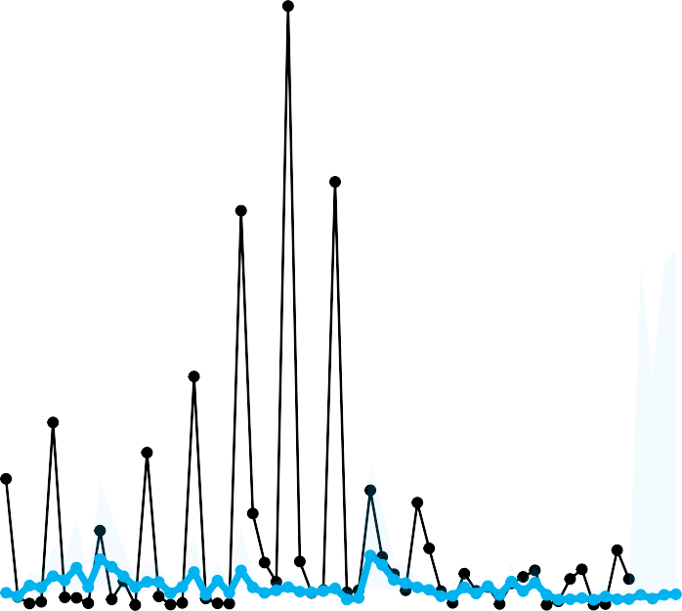
1980 2000 2020

year | fit | lwr | upr
55 2021 | 93607.72 | 2895.578 | 3026134
56 2022 | 59896.64 | 1756.122 | 2042915
57 2023 | 93729.80 | 2899.648 | 3029774
58 2024 | 98540.82 | 3059.607 | 3173706

Weighted Mean Forecast: 90401

60°N
50°N
Latitude
40°N
30°N
20°N
10°N
Spring CMISST MapCovariance
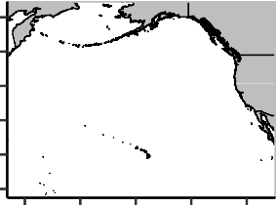
0.2
0.1
0.0
−0.1

Age

avg_age1 avg_age2 avg_age3 avg_age4

160°E180°160°W140°W120°W

Longitude
−0.2

3e+07

2e+07
Quesnel

1e+07

0e+00
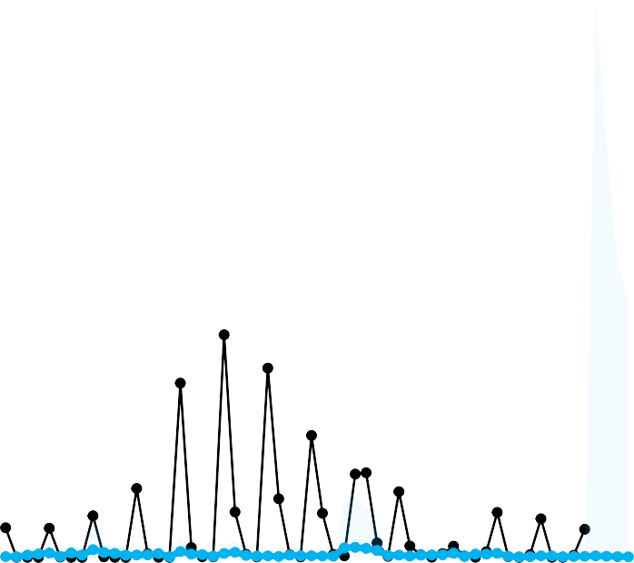

1980 2000 2020

year | fit | lwr | upr
55 2021 | 85994.84 | 236.30661 | 31294567
56 2022 | 62279.95 | 165.59695 | 23423091
57 2023 | 41069.22 | 101.63932 | 16594770
58 2024 | 33879.55 | 80.23572 | 14305651

Weighted Mean Forecast: 43150

Spring CMISST MapCovariance
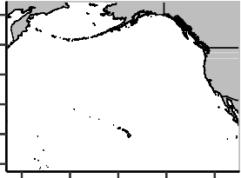
60°N

Age

50°N
Latitude
40°N
30°N
20°N
10°N
160°E180°160°W140°W120°W

Longitude
0.2

0.0

−0.2
avg_age1 avg_age2 avg_age3 avg_age4

150000

100000
Raft

50000

0

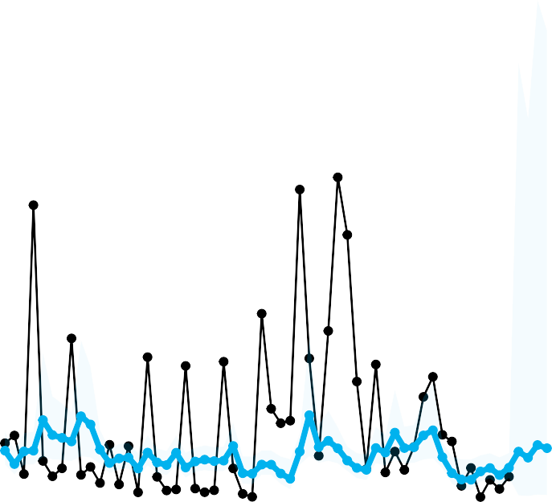
1980 2000 2020

year | fit | lwr | upr
55 2021 | 17745.05 | 1996.097 | 157751.3
56 2022 | 15543.78 | 1753.578 | 137780.7
57 2023 | 20106.05 | 2243.685 | 180173.8
58 2024 | 18959.89 | 2125.080 | 169159.6

Weighted Mean Forecast: 18963

60°N
50°N
Latitude
40°N
30°N
20°N
10°N
Spring CMISST MapCovariance


0.2

0.0

−0.2

Age

avg_age1 avg_age2 avg_age3 avg_age4

160°E180°160°W140°W120°W

Longitude

1500000

1000000
Stellako

500000

0

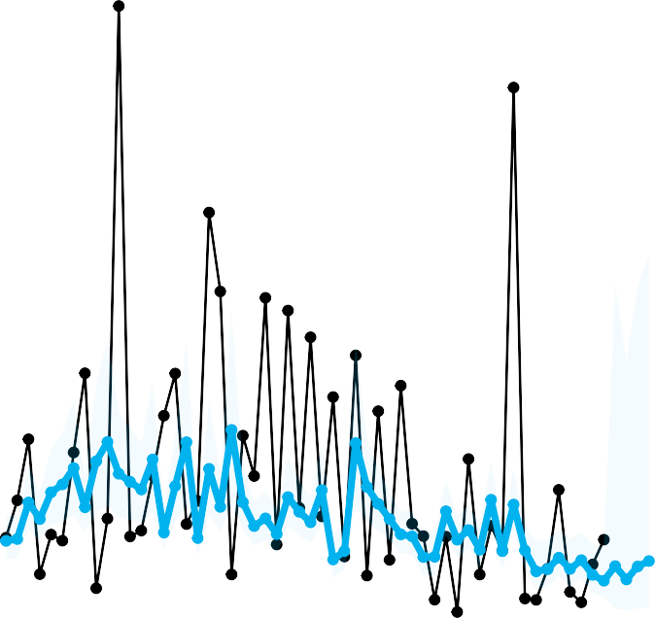
1980 2000 2020

year | fit | lwr | upr
55 2021 | 155033.1 | 23182.60 | 1036780.4
56 2022 | 113255.4 | 16127.02 | 795359.4
57 2023 | 153810.0 | 22976.61 | 1029634.9
58 2024 | 170882.6 | 25844.31 | 1129875.2

Weighted Mean Forecast: 147941

